DNA
DNA is the molecule organisms use to store their characteristics.

A chromosome is a strand of DNA, whereas a gene is a section of a chromosome that codes for a specific sequence of amino acids which form a protein.

DNA is a double-helix shape, with 2 polynucleotide strands.

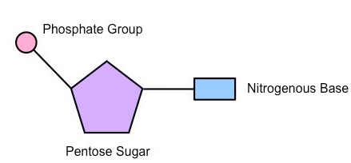
DNA strands are formed from nucleotides, where each nucleotide is a pentose sugar bonded to a phosphate ion and a nitrogenous base.

DNA uses a deoxyribose sugar

There are 4 bases in DNA:
- Adenine
- Thymine
- Cytosine
- Guanine

Where A&G are called the purines (they have 2 rings), and C&T are called the pyrimidines (they have 1 ring).

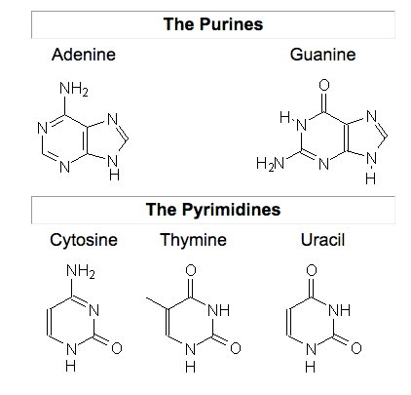

Purines bond only to pyrimidines because their orientation. This is called complementary base pairing, as one side of the strand determines the sequence of the other side.

An A-T bond uses 2 hydrogen bonds, whereas a C-G bond uses 3 hydrogen bonds.

Bases of the 2 DNA strands only fit together when the sugars they are attached point to point in opposite directions, this is an antiparallel strand.

DNA strands are joined by hydrogen bonds, and nucleotides are joined together by phosphodiester bonds.
RNA

RNA is similar to DNA, but only has 1 strand, and uses a ribose sugar instead of the deoxyribose sugar that DNA uses.

RNA also uses the Uracil base instead of the Thymine of DNA.

The Genetic Code

The genetic code is the sequence of bases in DNA or RNA, which determines the sequence of amino acids in proteins.

Genes are arranged in codons, where each codon is 3 bases. There are 64 different arrangements of codons, as there are 4 bases, and 4³ = 64.

There are approximately 20 amino acids in the body so 64 combinations are more than enough codons to code for all of them.

Codons are:
- Universal – The same codon codes for the same amino acid in all organisms on earth.
- Degenerate – More than one codon codes for the same amino acid, e.g. UAU and UAC both code for tyrosine.
- Non-overlapping – Each base is only part of one codon, codons are kept separate.
- Triplet – Codons are read in groups of 3.

